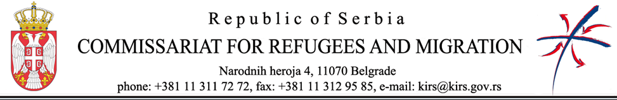

SUPPLIES CONTRACT AWARD NOTICE
“Supply of Drinking Water”
The Republic of Serbia, RS

1. Type of procedure
Open

2. Publication reference and date of the contract notice
EuropeAid/2020/418-074/404-75

3. Lot number and lot title
N/A

4. Contract number and value

Contract number: 404-75/8; value: 5.984.100, 00 RSD

5. Date of award of the contract
5.11.2021.

6. Number of tenders received
2 (two)

7. Name, address and nationality of successful tenderer
RIT DOO za poljoprivrednu proizvodnju Čoka, Potiska 59, 23320 Čoka, Serbia, RS
8. Duration of contract
Until the 23rd of April 2022
9. Contracting authority
Commissariat for Refugees and Migration of the Republic of Serbia
10. Legal basis
Regulation (EU) No 236/2014 of the European Parliament and of the Council of 11 March 2014 laying down common rules and procedures for the implementation of the Union's instruments for financing external action and Regulation (EU) No 231/2014 of the European Parliament and of the Council of 11 March 2014 establishing an Instrument for Pre-Accession Assistance (IPA II)

